Postal Life Insurance

Department of Post

Software Requirements Specification (SRS)/ Functional Requirements Specification (FRS)
  - Office Hierarchy Management

INTERNAL APPROVAL FORM

Project Name: Office Hierarchy Management
Version: 1.0
Submitted on:
 | Name | Date
Approved By:
Reviewed By:
Prepared By:

VERSION CONTROL LOG
Version | Date | Prepared By | Remarks
1

Table of Contents

1. Executive Summary 4
2. Project Scope 4
3. Business Requirements 4
4. Functional Requirements Specification 5
4.1 Office Management Dashboard 5
4.2 Add / Edit Office 6
4.3 Upgradation/Downgradation 6
4.4 Office Closure 6
4.5 Audit Trail 7
5. Appendices 7

1. Executive Summary
The purpose of this document is to define the requirements for the Office Hierarchy Management Module within the Insurance Management System (IMS) of India Post PLI. This module will enable the management of the hierarchical structure of post offices, administrative units, and their associated users for efficient insurance operations.
The module supports the addition, upgradation, downgrading, closure, and modification of offices and user roles mapped to them.

2. Project Scope
The Office Hierarchy Management module shall allow authorized administrators to:
- Create and manage offices (HO, DO, BO, CPC, Circle Office, etc.).
- Perform hierarchy operations: addition, upgradation, downgrading, merging, closure.
- Manage mapping of users to offices.
- Ensure role-based access and permissions.
- Maintain audit trail and history of structural changes.
- Integrate with other IMS modules (Policy Admin, Claims, Reports) through APIs.

3. Business Requirements
Requirement ID | Requirements
FS_OH_001 | The system shall maintain a centralized hierarchical master of all India Post PLI offices.
FS_OH_002 | The system shall allow addition of new offices (HO, DO, BO, CPC, Circle).
FS_OH_003 | The system shall support upgradation and downgrading of offices based on operational changes.
FS_OH_004 | The system shall allow closure of an office after necessary approval.
FS_OH_005 | The system shall maintain parent-child relationships between offices.
FS_OH_006 | The system shall capture effective dates for all structural changes.
FS_OH_007 | The system shall maintain complete audit trails of all changes with user IDs and timestamps.
FS_OH_008 | The system shall restrict unauthorized access using role-based control.
FS_OH_009 | The system shall integrate with the User Management module to remap users automatically after office structural changes.
FS_OH_010 | The system shall generate reports of hierarchy status and historical changes.
FS_OH_011 | The system shall validate office codes and prevent duplication.
FS_OH_012 | The system shall allow searching, filtering, and exporting of office hierarchy data.
Sample Office Hierarchy Tree:
Circle Office (Delhi)
├── Head Office (Delhi HO)
│ ├── Divisional Office (South Delhi DO)
│ │ ├── Branch Office (Lajpat Nagar BO)
│ │ └── Branch Office (Malviya Nagar BO)
│ └── CPC (Delhi CPC)
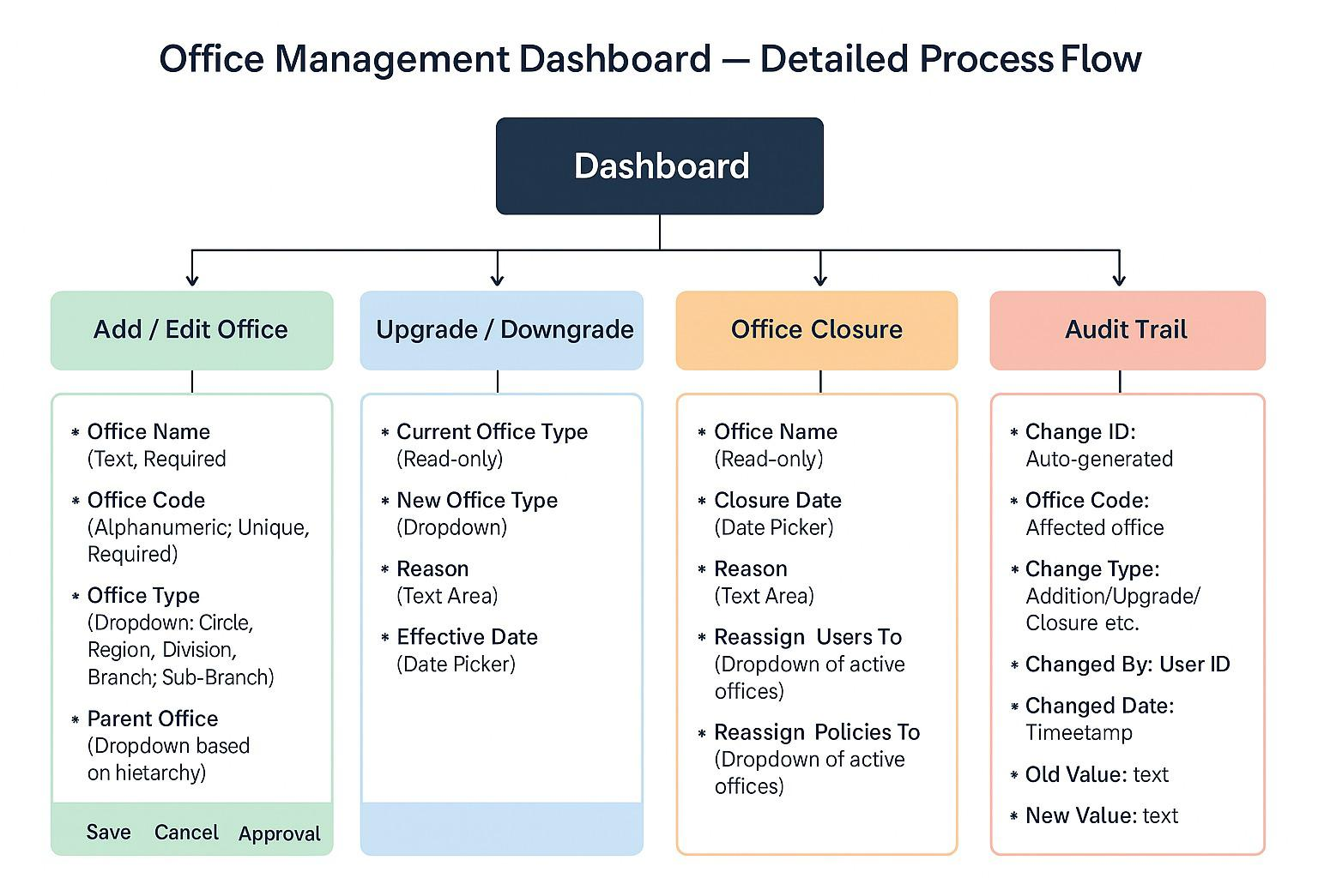

4. Functional Requirements Specification

4.1 Office Management Dashboard
Central console for viewing and managing the office hierarchy.
Fields:
- Office Name
- Office Code
- Office Type (Circle, Region, Division, Branch, Sub-Branch)
- Parent Office
- Status (Active, Closed)
- Date of Establishment
- Date of Closure (if applicable)
- Reason for Closure/Upgrade/Downgrade
- Number of Users
- Number of Policies

Actions:
- Add Office
- Edit Office
- Upgrade/Downgrade
- Close Office
- View Hierarchy
- Bulk Upload
- Export to Excel/PDF

4.2 Add / Edit Office
Create or modify an office record.
Fields:
- Office Name (Text, Required)
- Office Code (Alphanumeric, Unique, Required)
- Office Type (Dropdown: Circle, Region, Division, Branch, Sub-Branch)
- Parent Office (Dropdown based on hierarchy)
- Address (Text Area)
- Contact Number (Numeric)
- Email (Email Format)
- Date of Establishment (Date Picker)
Actions:
- Save
- Cancel
- Submit for Approval

4.3 Upgradation/Downgradation
Change the level/type of an existing office.
Fields:
- Current Office Type (Read-only)
- New Office Type (Dropdown)
- Reason (Text Area)
- Effective Date (Date Picker)

4.4 Office Closure
Mark an office as closed after approval.
Fields:
- Office Name (Read-only)
- Closure Date (Date Picker)
- Reason (Text Area)
- Reassign Users To (Dropdown of active offices)
- Reassign Policies To (Dropdown of active offices)
Validations:
- Mandatory reassignment of users and policies
- Closure date must be >= current date

4.5 Audit Trail
Track all changes made in office hierarchy.
Fields:
Change ID: Auto-generated
Office Code: Affected office
Change Type: Addition/Upgrade/Closure etc.
Changed By: User ID
Changed Date: Timestamp
Old Value: text
New Value: text

5. Test Cases
The Following Documents attached below can be used.
TC ID | Short Name | Description | Expected Result
TC_OH_001 | Centralized Hierarchy Master | Verify that the system maintains a centralized hierarchical master of all offices. | All offices (HO, DO, BO, CPC, Circle) are visible in a single hierarchy view.
TC_OH_002 | Add New Office | Validate addition of a new office type (HO, DO, BO, CPC, Circle). | New office is successfully added with correct details and appears in hierarchy.
TC_OH_003 | Upgrade Office | Test upgradation of an office (e.g., BO → DO). | Office type changes successfully; hierarchy updates accordingly.
TC_OH_004 | Downgrade Office | Test downgrading of an office (e.g., DO → BO). | Office type changes successfully; hierarchy updates accordingly.
TC_OH_005 | Close Office | Validate closure of an office after approval workflow. | Office status changes to “Closed”; hierarchy reflects closure.
TC_OH_006 | Parent-Child Relationship | Verify parent-child linkage between offices. | Correct parent-child relationships maintained after changes.
TC_OH_007 | Effective Dates | Validate capturing of effective dates for structural changes. | Effective date is stored and displayed in audit/history.
TC_OH_008 | Audit Trail | Check audit trail for all changes with user ID and timestamp. | Audit log shows correct user, timestamp, and change details.
TC_OH_009 | Role-Based Access | Validate that unauthorized users cannot modify hierarchy. | Unauthorized users receive “Access Denied” message.
TC_OH_010 | User Remapping | Verify integration with User Management for automatic user remapping after office changes. | Users are reassigned to correct office automatically.
TC_OH_011 | Hierarchy Reports | Validate generation of hierarchy status and historical change reports. | Reports are generated accurately with current and past data.
TC_OH_012 | Office Code Validation | Check validation of office codes and prevention of duplicates. | Duplicate office codes are rejected with error message.
TC_OH_013 | Search & Filter | Validate searching and filtering of office hierarchy data. | Search and filter return correct results based on criteria.
TC_OH_014 | Export Data | Verify export functionality for hierarchy data (CSV/Excel). | Data exports successfully in selected format.

6. Appendices
The Following Documents attached below can be used.

